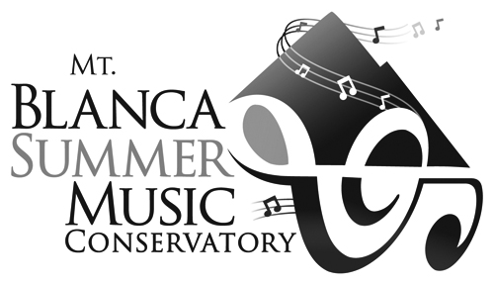

Mt. Blanca Summer Music Conservatory Application Form

To apply: Complete the application in full and sign. Include an audition recording (CD/DVD) and/or teacher recommendation letter, list of current repertoire and a non-refundable application fee payable to Mt. Blanca Fine Arts Association (please put Mt. Blanca Summer Music Conservatory on the memo line). If applying for a scholarship please include: a short essay on why you would like to attend the conservatory and two recommendation letters (one being from your private teacher).

Mail to: Mt. Blanca Summer Music Conservatory
P.O. Box 175
Fort Garland, CO 81133

DATE:_______________________________________________

APPLICANT NAME:_______________________________________

MALE:______FEMALE:_____

APPLICANT BIRTHDATE:____________________________________

INSTRUMENT:_____________________________________YEARS STUDIED:_______

SCHOOL:________________________ GRADE/LEVEL:____________________________

PARENTS NAME:_______________________________________________

ADDRESS:______________________________________________________

CITY:_____________________STATE:______________ ZIP:___________________

PARENT EMAIL:______________________________________________________________

STUDENT EMAIL:________________________________________________________

PARENT PHONE (HOME):______________________________________

PARENT PHONE (CELL/WORK):_____________________________________

STUDENT CELL:_______________________________________

TEACHER NAME:_______________________________________________

TEACHER PHONE:__________________________________________

TEACHER EMAIL:________________________________________________

Is the student applying for a scholarship?
YES______ NO________

Will the student be accompanied by a parent or legal guardian? YES____ NO _____

HOUSING: please check one
Shared Room (for unaccompanied students only): _________
Single Room (for accompanied students only):___________
Whole Suite (for accompanied students only):____________
Off-campus:____________

*** Please include the following with this application:
1.)$50.00 non-refundable application fee
2.) List of current repertoire including method/scale/etude books
3.) Audition recording of one solo piece best representing the students ability OR a recommendation letter from the students current teacher.
4.) If applying for a scholarship please include a short essay on why you would like to attend the Conservatory and one other recommendation letter from someone other than your current teacher.
*NOTE: Application materials will NOT be returned.

Application Agreement:
If accepted as a student of the Mt. Blanca Summer Music Conservatory (MBSMC), I agree to abide by the regulations of MBSMC. I agree not to bring any alcoholic beverages on the premises of Adams State University, Colorado, or to possess or to engage in the unauthorized use of drugs or controlled substances while a student of MBSMC. MBSMC reserves the right to expel any student for violations of its rules and regulations without refunding any part of the tuition or fees paid. Consent is hereby given for the applicant, while a student with MBSMC, to participate in MBSMC sanctioned programs without compensation and for photographs/videos taken by MBSMC to be used in publications or on the websites.
I understand that all balances must be paid in full by June 25, 2017.

STUDENT SIGNATURE: ___________________________________________________

PARENT/GUARDIAN SIGNATURE:_______________________________________

DATE:_______________

Application and non-discrimination policy:
All applicants to Mt. Blanca Summer Music Conservatory must complete this application form. Admission to the programs of the Mt. Blanca Summer Music Conservatory is open to all qualified applicants. MBSMC does not discriminate on the basis of race, color, ethnic or national origin, creed, gender or physical handicap in the administration of its educational policies, admissions policies, or any other programs.

